NextShift AI — Week 3 project documentation
Maven · Mastering Agentic AI · Week 3 “Build Your AI Agent” · Judy Darvin · submitted 2026-08-31 Repo: https://github.com/judy-eapen/nextshift-ai · Interactive architecture (FigJam): student journey · professional journey

1. Overview
One-liner (handout Part 2): My agent helps a student who doesn’t yet know what they want, or a professional worried about their role, plan a career for an AI-shaped job market in a web app — replacing hours of podcasts, headlines and Reddit threads that never say how confident anyone is or what to do. It restates what it understood about the person, gathers employment projections, task-level AI-exposure data and forecaster expectations in parallel using 10 read-only tools across 4 gatherers, writes a plan that leads with the answer, has a second model strip every line it can’t verify, hands off to the person before any evidence is gathered (to confirm it understood them) and before anything is saved, and I’ll know it works when a person gets a cited, actionable plan that addresses each of their stated concerns in under 10 minutes, 8 times out of 10.
The problem. Students don’t know which fields will still offer meaningful work; professionals don’t know whether their role will shrink, how it will change, or what to learn. The information exists — BLS projections, O*NET task lists, Anthropic’s data on what AI is actually used for, prediction markets on AI progress — but nobody assembles it for one person’s situation, and the sources that do exist rarely say how sure they are.
The product promise. NextShift helps students and professionals understand how AI may change a career, whether demand is likely to grow or shrink, and what they can do now to build a more resilient future — without promising any career is “safe.”
What a student sees. Start → two choices. Explore careers — a Career Explorer over 1,017 real occupations (every O*NET 31.0 code + a curated composite; stated as “not every job that exists”): search by title or plain words (“helping animals”, “working outdoors with plants”), browse 16 families, 18 school subjects, 7 “what you like doing” traits and discovery collections (careers you may not know exist · fast-growing · AI already touches many tasks · in-person work stays central · growing AND AI-heavy · declining). Every page is deterministic and instant — zero model calls — and every figure carries its source, year and retrieval date; a missing figure says “Data not available from the current sources.” Career pages lead with four stat tiles (jobs today · direction to 2035 · AI in the tasks · top skill) and a reviewed narrative brief that retells those numbers conversationally; the full 15-question detail (four labelled layers: official source · derived by a fixed rule · written by AI & reviewed · personal to you) sits one click away in collapsed expanders, and every explorer page has a shareable URL. Students save careers, react (interesting · maybe · not for me · understand better), compare up to four side by side with no score — then, optionally, hand it all to the second choice. Help me find my direction — a career-discovery interview, one question at a time (8–12; the next question depends on what is still unclear, on contradictions, and on the student’s choices: I’m not sure · Skip · Recommend careers now · Ask me more · Edit an earlier answer) → “Here’s what I understand about you” in nine editable sections (gate 1; no career data has been gathered yet) → 8–10 career directions in three groups — strong matches · worth exploring · unexpected possibilities — each with a rationale that cites the student’s own words, official outlook, education, how AI may reshape the work, human capabilities, a possible mismatch and evidence confidence → reactions (😀 🤔 ✕ + why) that update the profile → 0–2 discriminating questions → a shortlist with eight dimensions shown separately and “Our read” labelled as interpretation → a deep dive with ten sections including Test this career before committing → what-ifs (no grad school? salary? remote?) that reorder within the same candidates → save (gate 2). When the student arrives from the explorer, saved careers enter the interview as quoted evidence (“Saved in the Career Explorer… Saving is not choosing.”) and up to three targeted comparison questions are templated from the careers’ O*NET profiles (“You saved Architects and Psychologists — visual creation, or working out what people need?”).
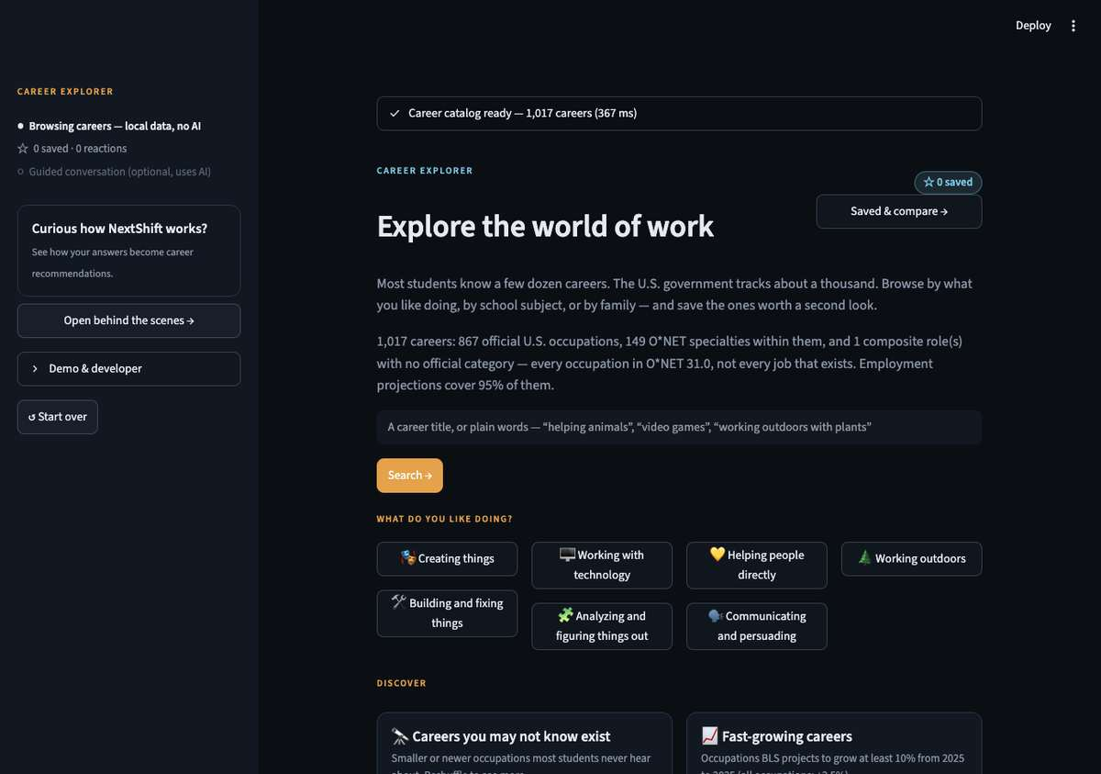
Career Explorer home — browse 1,017 careers instantly, no model calls
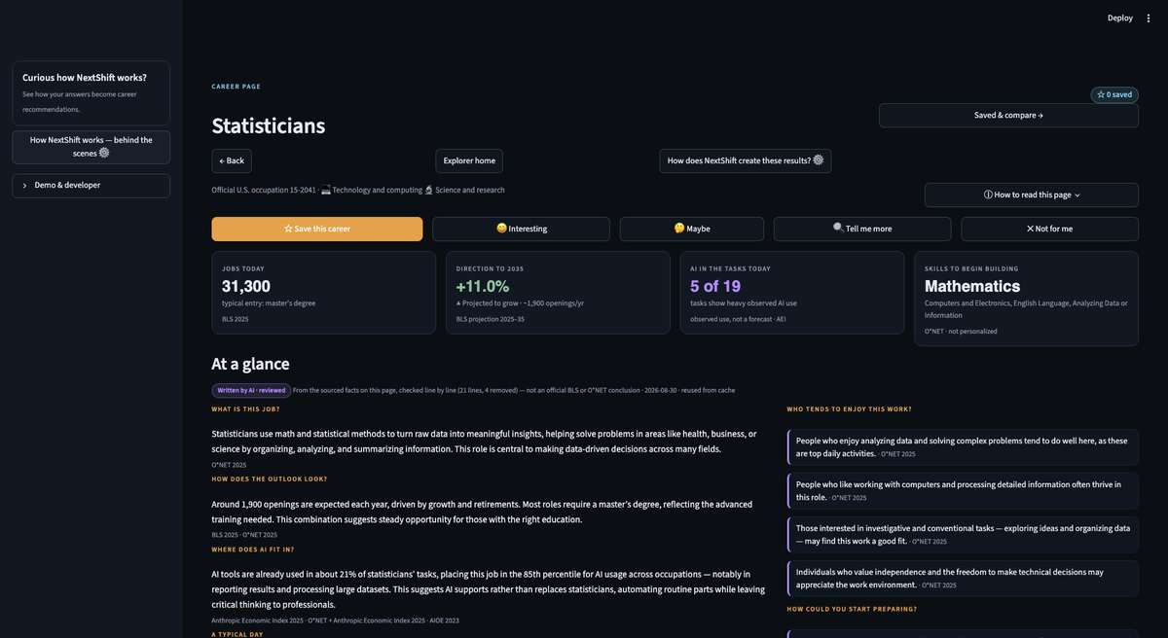
A career page: stat tiles, then the reviewed narrative brief with per-paragraph source footnotes
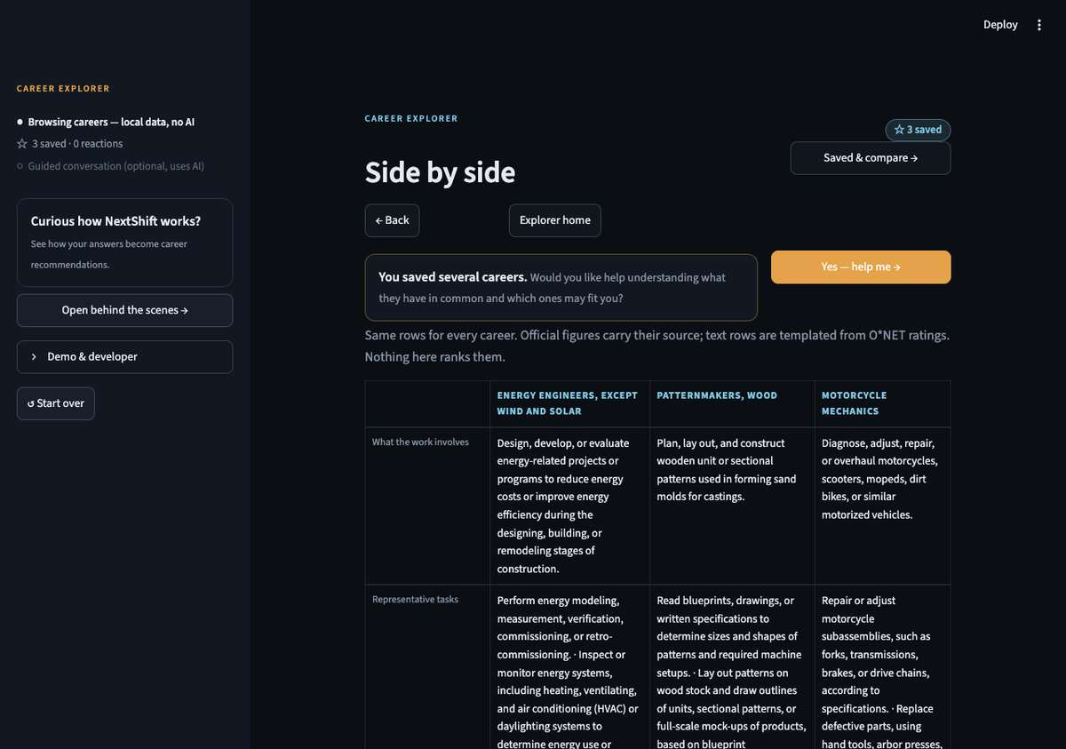
Compare up to four careers — same rows, no score
What a professional sees. Start → two doors → 4-turn guided intake → “Here’s what I understood — fix anything that’s off” (gate 1) → plain-language progress → Your plan: direct answer · 1 outlook · 2 how the work may change · 3 what this means for you · 4 preparation plan (30 days / 6 months / 1 year) · 5 other paths · 6 confidence & uncertainty · 7 ▸ how we reached this answer → approve / edit / reject (gate 2) → saved; a later run shows what changed.
How the system explains itself. A sidebar Your journey indicator (nine student steps / seven professional) is derived from the graph’s stage and node phase events — never from a timer — and flags partial evidence and UNVERIFIED where they actually occurred. Open behind the scenes → opens a dialog with three levels: How NextShift works (seven plain-language steps tagged [you] / [code] / [AI], with “you are here”), What is saved? (wording verified against the checkpoint and memory code — including that interview answers sit in a resumable session file before approval and go to the model provider), and For builders (architecture, model-assisted vs deterministic work, state and memory, failure handling, diagrams). Each career card offers Why this appeared →: what you told us (your quoted words) and career evidence, from the reviewed objects only — no score, nothing generated in the UI. Developer mode (NEXTSHIFT_DEV=1) is the only place model names, cost and node timings appear, and the only mode in which LangSmith tracing is on.

2. The agent framework (handout Part 2)
Field | Answer
Agent goal | Take a person’s role or interests, their concerns and a horizon; return a cited career plan: outlook, how the work changes, what to do in 30 days / 6 months / 1 year.
Where used | Web app (Streamlit).
Steps, in order | 1 Resolve the occupation (exact title → semantic → composite assembled from 18K O*NET task statements when no category exists) → 2 restate what was understood → 3 ⏸ understanding gate → 4 gather evidence in parallel, per occupation (outlook · exposure · forecasts · research) → 5 reconcile: dedupe, disagreements, unknowns, diff vs last snapshot → 6 outlook + three task groups (code) → 7 write the plan (planner model) → 8 reviewer strips unsupported lines (different model; one rewrite if >30%) → 9 render → 10 ⏸ plan gate → 11 save plan + snapshot.
Tools | READ: bls_projections(soc) · bls_oes · onet_tasks(soc) · onet_web_services · anthropic_index(soc) · aioe(soc) · polymarket_search · manifold_search · metaculus_search · epoch_recent · fred_series. WRITE (gated): save_plan, save_snapshot, save_profile. INTERNAL: occupation resolver + task-statement matcher (Nebius embeddings), market relevance filter.
Remembers | Across sessions: profile + one evidence snapshot per approved run (SQLite) so the next run reports what moved. Within a run: the typed LangGraph state, checkpointed in SQLite (required for interrupts/resume).
Never does | Guarantee a job is safe or doomed · state a number not on a card · turn “AI is used for this task today” into “this task is automated” · infer a task “grows” from low AI usage · average disagreeing forecasts · invent a course or product · write anything before the plan gate.
Human in the loop | Professional: gate 1 (understanding) before any tool spend; gate 2 (plan) before save. Student: every interview question is an interrupt (answer · not sure · skip · recommend now · ask more · edit earlier), then the understanding gate, reactions, discriminating questions, shortlist choices, exploration and a save gate — seven interrupt kinds on one thread. All are LangGraph interrupts resumed with Command(resume=…).
When something breaks | Every tool returns SourceResult(ok, cards, error, unknowns) — never raises. Retry ×2 with backoff; then the source is marked unavailable and the plan carries a “Partial evidence” badge. No forecast → a cited unknown, never a number. Reviewer model down → citation-only check, flagged in the UI. Budget: 40 tool calls / $1.
How I know it worked | 12-case professional golden set plus a 24-case student sweep, both journeys, run end to end through both gates: ≥N cards, zero uncited factual lines, correct demand reading, unknowns/disagreements surfaced where expected, no write before approval, <10 min — plus a 5-point answer-quality rubric judged by the reviewer model (answers every concern · facts kept apart from interpretation · no guarantees · no invented products · concrete 30-day actions). Result: professional 12/12 after two prompt fixes (median ~3 min; ~$0.01 per plan); student 24/24 (median ~9–10 min; ~$0.07 per exploration).

3. Architecture
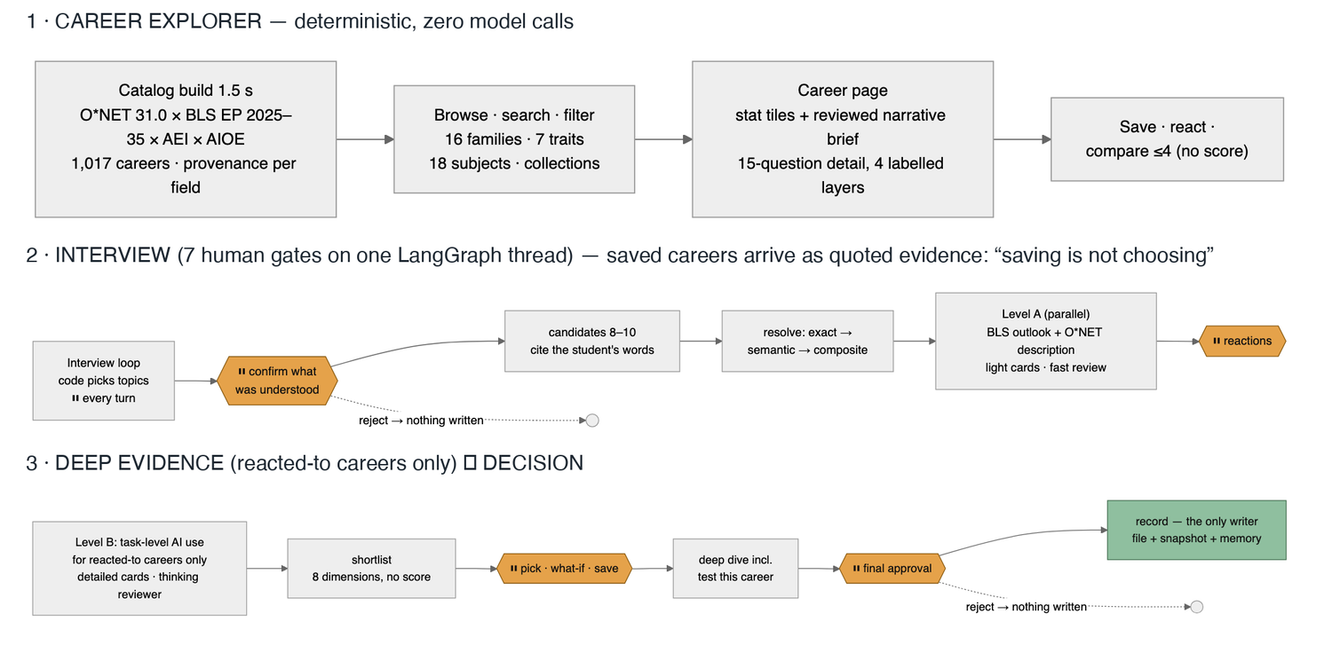
Student journey — Career Explorer, interview with 7 human gates, two-level evidence, record as the only writer
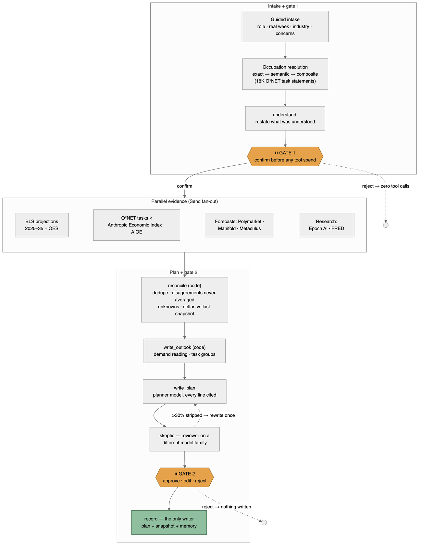
Professional journey — intake and gate 1, parallel evidence, plan and gate 2
Interactive, zoomable versions: student journey (FigJam) · professional journey (FigJam). Full engineering renders: design/architecture-student.png, design/architecture-diagram.png in the repo.
Pattern: two LangGraph graphs. Professional: supervisor, 14 nodes, 2 interrupts (diagram above). Student: interviewer, 38 nodes, 7 interrupt kinds, one thread (design/architecture-student.png) — two evidence levels: lightweight cards for every direction before the student reacts, task-level AI evidence and the thinking reviewer only for the reacted-to careers — the interview loop is a conditional cycle (select_question → interview_gate → update_profile → evaluate_completeness) whose exit is decided in code.
Model roles. Six model-driven roles — understand, market relevance filter, outlook interpreter, “more important” judge, plan writer (all Qwen3-235B-Instruct via Nebius) and the reviewer (Qwen3-Next-80B Thinking — deliberately a different model family so review doesn’t share the writer’s blind spots) — plus four deterministic gatherers that fan out with Send per occupation and merge through reducers. Numbers, groupings and probability ranges are always computed in code over evidence cards; models write prose and judgments only.
Why not a single agent (iteration story below): I started single-agent; the parallel source calls were the latency bottleneck, and same-model self-review kept approving its own overreach. Splitting gatherers (independent work) and the reviewer (independent judgment) were the two justified reasons to go multi-agent.
Grounded hybrid (Career Explorer). The model is never the source of a labor-market fact. tools/career_page.py types four layers that cannot mix: SourcedFacts (every field a Sourced{value, source, as_of, retrieved, url} or None, plus an unavailable list) → DerivedValues (Derived{value, rule, inputs}, fixed code) → Interpretation (a narrative brief: the model retells the page’s numbers in plain language — “projected up 11%, three times the average, which suggests steady opportunity” — generated ONLY from the page’s evidence table; every factual sentence cites [cNN]; deterministic lints remove uncited lines, numbers not on the cited card, certainty and absolute-fit/safety language; then the same reviewer model as the plans; sources shown as one footnote per paragraph; disk-cached per career × data version × prompt × models and precomputed for ~23 common careers; an UNVERIFIED result is never cached) → PersonalizedGuidance (only the interview produces this). Measured: one generation ≈ 110 s (the reviewer is ~100 s of it), 8 of 35 lines removed — uncited paragraphs, an X≠Y citation, “handled by automated systems”, two “will remain essential” — then reused from cache in <1 ms.
Runs entirely on open-weight models through Nebius Token Factory.

4. Datasets and sources
Family | Source | What it gives | Access
Outlook | BLS Employment Projections 2025–35 (Table 1.2) | growth %, numeric change, annual openings, typical entry education | manual xlsx download (scripted download is 403’d)
Outlook | BLS OES 2025 | employment, median wage per SOC | API
Exposure | O*NET 31.0 task statements (17,998), occupation data, reported job titles (54K) | the task list per occupation; the title→SOC index | download + Web Services key
Exposure | Anthropic Economic Index | task_penetration — share of observed AI conversations touching each O*NET task; job_exposure per occupation | HF download, pre-aggregated offline
Exposure | AIOE (Felten et al.) | AI occupational exposure score, LM variant | GitHub CSV
Forecasts | Polymarket · Manifold · Metaculus | market-implied probabilities on 6 curated anchor questions (AGI by horizon, drop-in AI workers, AI-driven unemployment, AI safety law, adoption) | public APIs; Metaculus aggregates gated for this account → honest value=None
Research | Epoch AI notable models · FRED | frontier-model releases; national unemployment | CSV · API
Explorer | O*NET 31.0 work activities · work context · career interest types (RIASEC) · related occupations · job zones | “what you like doing” traits, workday sentences, who-may-enjoy, official related careers, preparation level | onetcenter.org CSVs, no key
Explorer | BLS EP Table 1.12 (factors affecting occupational utilization) | the projection team’s own stated reasons an occupation’s share changes (incl. AI) — 493 occupations | same xlsx
Offline join: data/processed/landscape.parquet — 867 occupations × outlook × exposure (94% coverage) — and the Career Explorer catalog (python -m tools.catalog --force, 1,017 records in ≈1.5 s from local files; families/subjects/traits are reviewable rules in data/career_families.json, no model). Honest gaps rendered as unavailable: industries by occupation, licensing, specialty-level employment, composite figures. Embedding indexes (occupations; 18K task statements) built once with Nebius Qwen3-Embedding-8B.

5. Prompts used with Claude Code (vibe-coding log)
- “Read PLAN.md, GOOD_MORNING.md, graph/DESIGN.md and skim tools/schema.py and tools/smoke_test.py. Do not write code yet. Critique the proposed graph against PLAN.md’s Sunday scope… propose the final State, nodes, edges, and the two interrupts. Stop and wait for me.” → design conversation first (instructor’s advice); 10 changes to the overnight proposal.
- “Walk me step by step through what you have given me… like you’re talking to somebody who doesn’t understand any of it.” → the design explained as a story; three decisions made (persona resolution in the UI, model writes the brief but the skeptic checks the brief itself, six curated forecast anchors).
- “How many agents are there?” → strict count (6 model-driven) vs loose count; the write-up line.
- “How valuable is this to someone today?” → honest 5/10 as a product; led directly to leading with the task view and to the redesign.
- “Go, start building.” → Friday’s graph, CLI, golden set 10/10.
- “This is not a PM job at all.” (screenshot) → discovered SOC has no Product Manager; resolver bug (.00-only index) fixed; then composite occupations from 18K task statements — “the government has no category for my job, so the agent assembled one and showed me its work.”
- “Yes build it, do both.” → curated + description-built composites, tick-list.
- “You are helping me redesign the user experience… First critique… wait for my approval.” → the 11-part redesign proposal; approved with “student for Sunday as well.”
- “Rerun g03 after the fix and show me the direct answer.” / “How did g13 do?” → eval-driven iteration overnight.

6. Iterations (what changed and why)
# | What I tried | What happened | What I changed
1 | Single agent, sequential tool calls | Slow; the one model approved its own overreach | Supervisor with parallel gatherers + separate reviewer model
2 | Cheap 30B model as the market relevance filter | Kept “Will Powell say ‘Unemployment’…” and “Will OpenAI hint at AGI” | Planner model, forced one-line why per market; announce-vs-happen markets kept only as labelled proxies
3 | Sentence-level skeptic on prose paragraphs | Regex splitting produced uncited fragments; 50% stripped | One claim per line (bullets); evidence header generated by code
4 | Residual probability for the “slow” scenario | Anchors aren’t mutually exclusive → fake 5% | Dropped residual; then dropped scenarios as the headline altogether
5 | “Product Manager” → Marketing Managers (where O*NET files the title) | Task list was pricing, campaigns, trade shows — not a PM’s week | Resolver over detailed codes; composites assembled from task statements; human ticks the tasks
6 | penetration × scenario multiplier → disappears / supervised / grows | Indefensible: current usage ≠ automation; low usage ≠ growth | Three groups from observed use only; “more important” requires a stated reason and is tagged interpretation
7 | Scenario tree as the result | Users couldn’t find the answer | Answer-first plan; forecasts demoted to conditional context in §6
8 | Worldview gate (edit forecast anchors) | Asked the user to approve concepts they don’t have | Understanding gate: confirm what the agent understood about them, before any tool spend
9 | Reviewer stripped 52% of the student plan | Bug: refs above c99 didn’t match a 2-digit regex | Fixed; strip rate fell to 0–3%
10 | Eval rubric said 30-day plans weren’t actionable | Judge saw only the first 6,000 chars — never reached §4 | Pass the whole plan to the judge; all cases pass
11 | Student intake as a 4-turn form asking for careers | Students who don’t know were stuck | Adaptive interviewer: code picks the goal by coverage gap and contradictions, model words the question
12 | Question writer told to “build on what they said” | Riffed on one moment for eight turns; constraints never asked | Topic lock: base question per goal, ≤8-word lead-in
13 | Reviewer judged a Markdown shadow while the UI showed the structured object | Removed claims could still appear on screen | Structured review: flatten → judge → delete in the object the UI renders; export generated afterwards
14 | Reviewer on 234 lines in one call (thinking model) | Output truncated → “unverified” | Batches of 12 in parallel, halving retry, raw-failure log; labels/ids skipped; rationale checked deterministically
15 | “Nonprofit Program Coordinator” → Clinical Research Coordinators | Semantic match on a shared generic word | Reject matches that share only generic words below 0.72 similarity → composite instead
16 | Architecture explained only in docs; the one in-app expander mixed model names and cost with unknowns and leaked raw log lines | Reviewers couldn’t see the gates, the deterministic controls or why a card appeared; a privacy line (“nothing is stored until you approve”) was inaccurate — answers are checkpointed to SQLite each turn and tracing was on | Progressive disclosure: journey indicator from real phase events · behind-the-scenes dialog (plain / what is saved / builders) · Why this appeared from reviewed data · developer mode gated by env, tracing follows it · copy pinned to code constants by tests
17 | Students entered through the interview only | You can’t express interest in a career you’ve never heard of; nothing was browsable before ≥10 model calls | Career Explorer: deterministic catalog, families/traits/collections/search, sourced career pages, save/react/compare — the interview became one path in, seeded by what was saved (never treated as a choice)
18 | First career pages mixed facts with model prose | Judy’s brief: the model “must not act as the source of factual career information” | Four typed layers with field-level provenance; lints (numbers must sit on the cited card, no absolute-fit or safety language, day-in-the-life labelled illustrative) before the reviewer

7. Learnings
- The hard part was never the prompt. It was where the gates go, what a “unit of claim” is for the reviewer, and what to do when a source is down or a category doesn’t exist.
- Make numbers in code, prose in models. Every defensible thing in the plan (demand reading, task groups, disagreement spread) is computed; the model only explains. This is what made the reviewer’s job tractable.
- A different model as reviewer catches real things — “fully automated” from a 0.92 usage score, a card about AGI probability cited for a task claim — and also exposed my own bugs faster than I would have.
- Honesty is a feature users notice. “No official category exists for your job; here’s what I assembled and how” landed better than any confident match. Same for “no forecast exists — not estimated.”
- The taxonomy gap is the thesis. SOC 2018 has no Product Manager, Product Owner or Head of Product. Official statistics lag how modern work is organized, which is exactly why a tool like this is needed.
- Explaining the system found an inaccuracy in it. Writing “what is saved?” against the actual checkpointer showed the interview line was wrong (answers are written to a session file before approval) and that tracing sent student text to LangSmith by default. Accurate copy forced accurate behaviour.
- Evals found the bugs I’d have shipped. Two of the four first-pass failures were harness bugs, two were prompt gaps; none were visible in a happy-path demo.

8. Evaluation results (evals/results/)
Student journey (24 cases, simulated students): see evals/student_golden.json — no career ideas · three careers in mind · “I don’t know” ×5 · recommend early · ask for more · edit the summary · correct an earlier answer · strict cost constraint · likes a field but dislikes its daily work · claimed vs demonstrated strengths · composite role · declining demand with many openings · BLS unavailable · Polymarket down · reviewer model down · reject profile · reject save · no write before approval · removed content absent from the UI · feedback changes the shortlist · concrete experiments · exploration preserves decisions · max turns · professional regression. Result: 24/24 across the sweeps (17 in the parallel sweep on current code, 7 rerun serially after a process stall; every case passes its deterministic checks and, where judged, the 5-point rubric). After the performance pass (lightweight first-round cards, deep evidence only for reacted-to careers, caches): full sweep 24/24, median ≈ 6 min and ≈ $0.03 per exploration. Before it: median ≈ 9–10 min and ≈ $0.07 per full exploration when run alone; parallel runs share one Nebius endpoint and slow each other down — run evals with EVAL_WORKERS=1 for timing.
Career Explorer (27 deterministic cases, 0 model calls): exact-title and plain-language searches, school subjects, unfamiliar-career discovery, growth/decline/high-exposure-but-growing collections, missing-data and composite cases, compare rows, family coverage — 27/27, sub-millisecond median (evals/run_explorer_evals.py). Unit tests grew 102 → 164, including: labor-market numbers can never come from model output, missing fields are not fabricated, every model explanation receives its source evidence, “good fit” language is non-absolute, AI exposure is never equated with job loss, cached interpretations are reused, browsing makes zero LLM calls, provenance survives to the rendered page.
Regression after the explorer build (2026-08-30): professional 11/12 in the sweep + the one miss (a removed-content-leak harness check) passing on immediate rerun; student 20/24 with s01/s19 passing on rerun and s08/s21 failing only model-judged rubric checks — verified to fail identically on the unmodified pre-explorer code in a clean worktree, i.e. judge-model drift, not a regression. No thresholds were changed.
Professional journey (12 cases):
12 cases · both gates · failure injection · memory (originally 13; g05, the old student 3-way comparison, was retired when the interviewer superseded it). First pass 9/13; after fixing the ref regex, the rubric truncation, and the plan prompt: 12/12. Median ≈ 3 min per plan, ≈ $0.01 per plan on open-weight models. Details: evals/golden.json, evals/run_golden.py, graph/DESIGN.md.

9. Roadmap (one slide)
Precomputed reviewed explanations for the most-viewed careers · plain-language career titles · accounts so saved careers persist · Adjacent-career paths from O*NET ability/knowledge similarity (data already local) · skill-gap learning paths · economy/retirement lens · watch-list alerts when a snapshot moves · Kalshi/Metaculus prices when access is approved · Next.js front end for a product (backend unchanged).

The whole system on one page
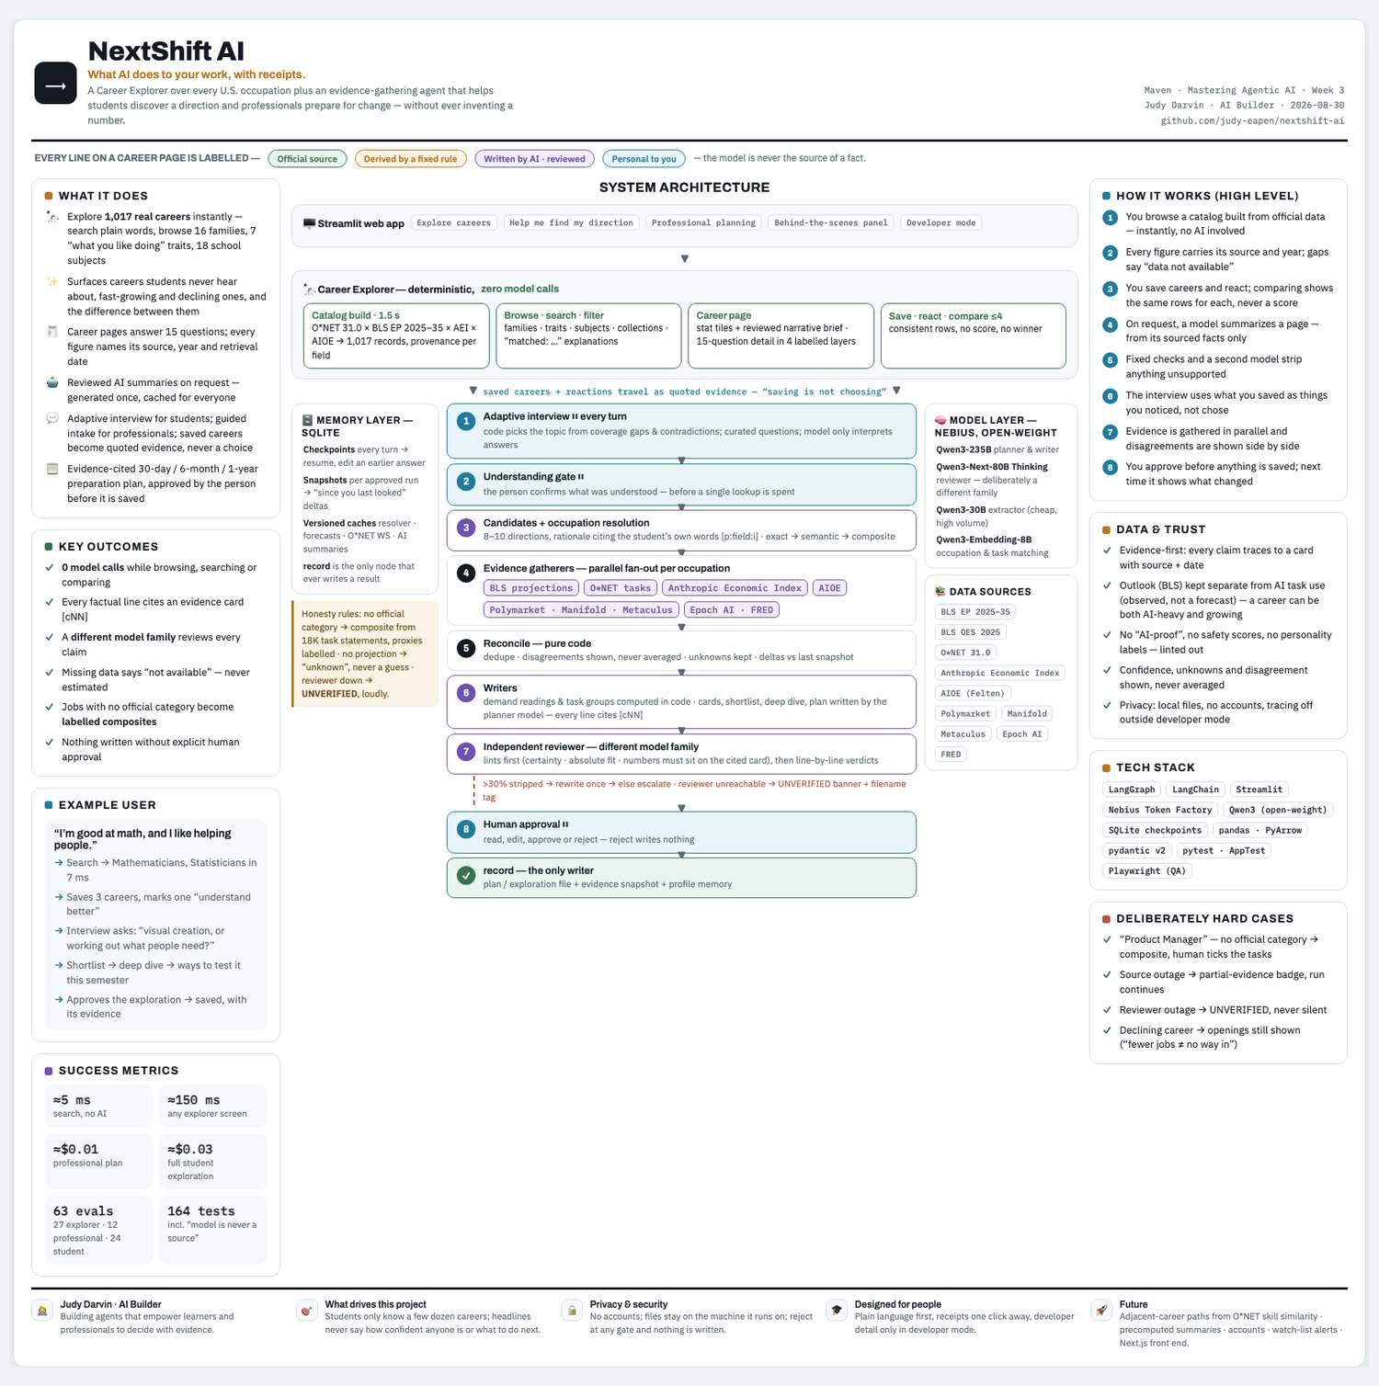
NextShift AI system poster

